# **ssignment 3**

## Registering for a University Course

1. Visit Course Registration System.
2. Browse available courses.
3. Select desired course.

Exception 🡪 Course not offered.

1. Add selected course to registration.

Exception 🡪 Unable to Pay.

1. Complete your Registration.

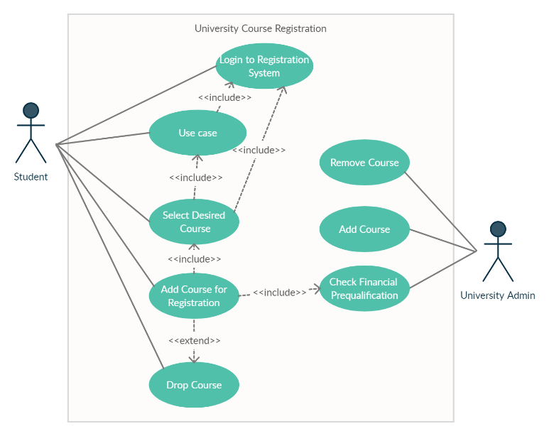

## Processing an Application for a Credit Card

1. Visit Bank website
2. Enter personal details

Exception 🡪 Invalid Details

1. Select the type of card.

Exception 🡪 Invalid Card Type

1. Check if you are prequalified.

Exception 🡪 No stable income source

1. Process Application.

Exception 🡪 Application Denied.

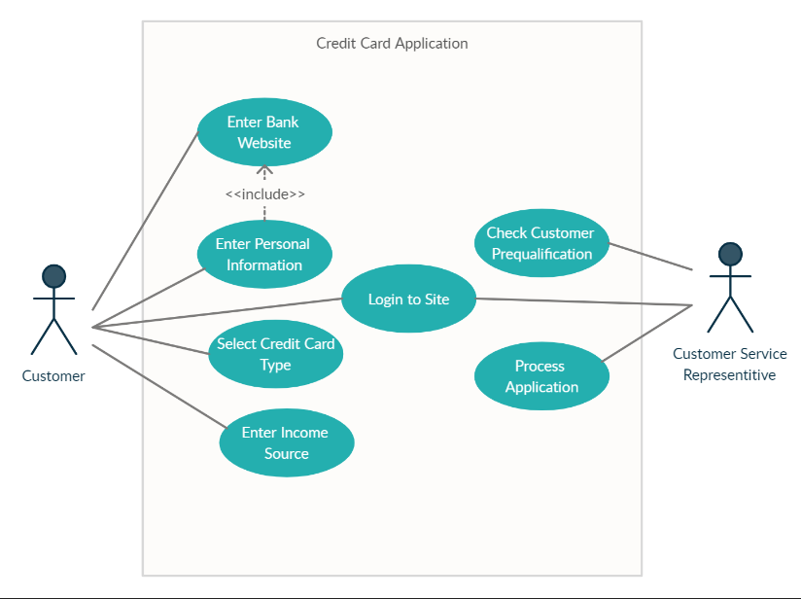

## Funds from one account to another

1. Login to your account.

Exception 🡪 Invalid Username or Password

1. Select Transfer Funds.
2. Select Source account.
3. Select Destination account.
4. Enter Destination account details.

Exception 🡪 Invalid Account No.

1. Enter Amount you want to transfer.

Exception 🡪 Insufficient amount in account.

1. Review.

Exception 🡪 Invalid Details.

1. Confirm.
2. Sign out.

